To register, you will first need to get a FEMA SID number. You can do that here 🡪 [Register for your FEMA SID (dhs.gov)](https://cdp.dhs.gov/femasid/register)

After you obtain your SID number, please visit [Preparing Texas New User Account Creation Form (office.com)](https://forms.office.com/Pages/ResponsePage.aspx?id=gz8N-aYA60COsl-41SZQllHbHk2UFLVEoZJOAR8SCfdUMkczN08xTUJTQVdSU1FWVENVWU5KRDFUOCQlQCN0PWcu)

** Note** If you had a previous account on Preparingtexas.org, they may have migrated your account to the new system. Your log in will be your FEMA SID number.

It will have you fill out a form which you will submit upon completion. The state will send you your account info after they create an account for you which can take up to 24 hours. Once you have an account, your user name will be your FEMA SID number and you will have to change your password.

After those steps are completed, please visit [tdem.geniussis.com/PublicWelcome.aspx](https://tdem.geniussis.com/PublicWelcome.aspx) and sign in. The screen will look like this:

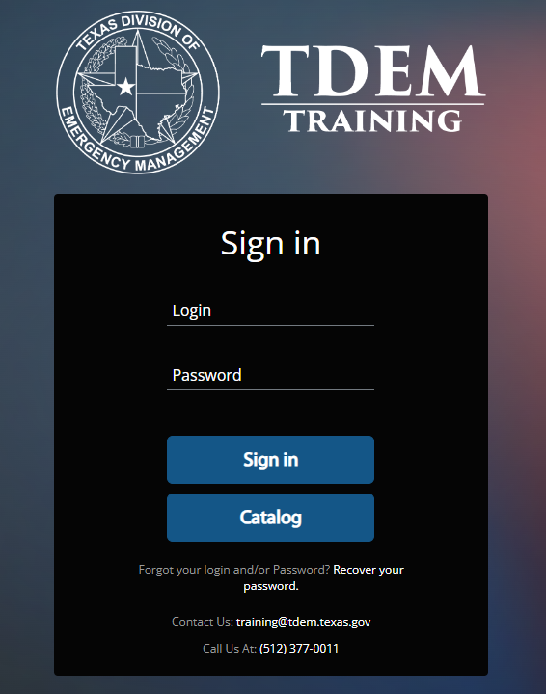

Once you sign in, it will take you to the dashboard. On the top right, make sure you click “New Dashboard” and then look at the left menu. Click on “register”

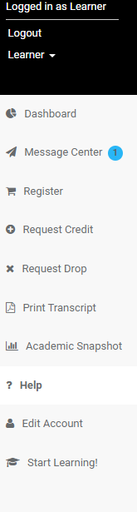

This will bring up a page with all of the courses listed in order. Scroll down until you find “G-317” and click on view offerings.

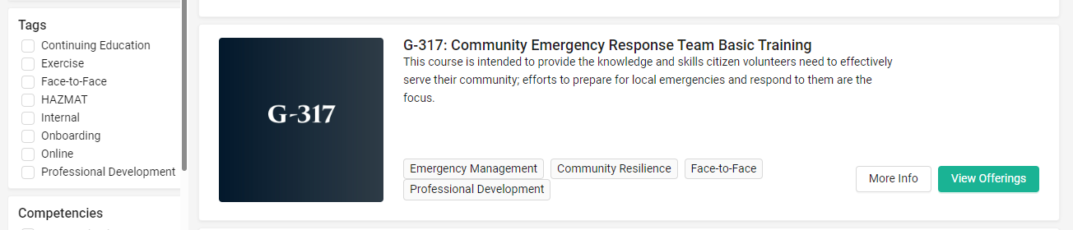

At the bottom of the page, you will see everywhere this course is offered in Texas. Our course should be the last one listed. Click on enroll.

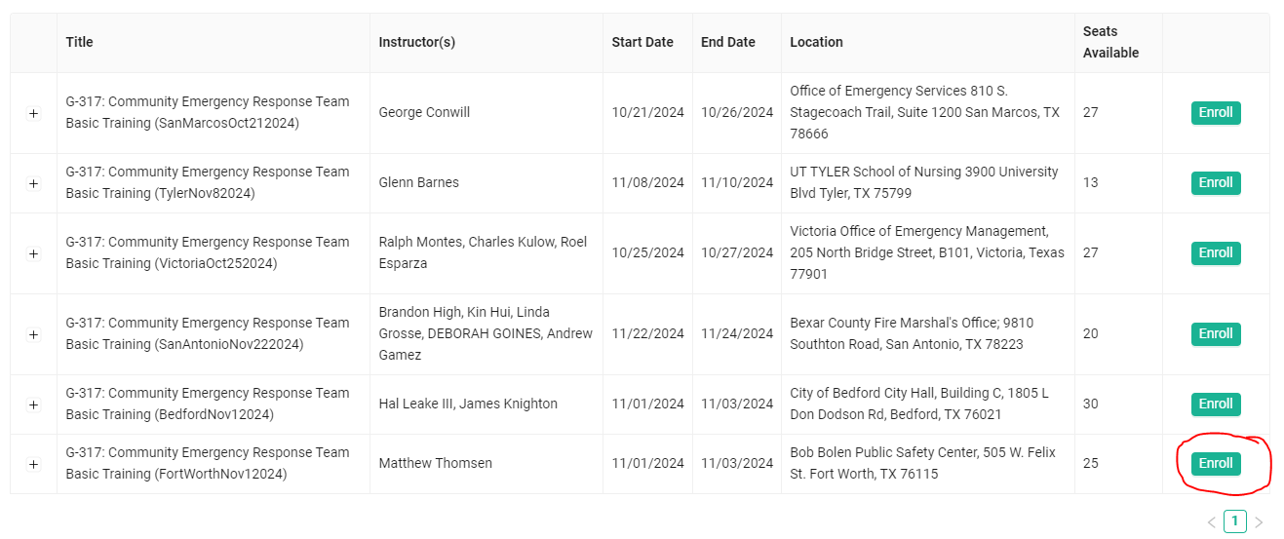

Once you click on enroll, it will send it to your cart like you are shopping online. Click on your cart and then click checkout. It will then take you to the confirmation page with the course and the location. At the bottom, click confirm and you are FINALLY signed up for the course.

This new system (Blackboard) is used primarily for colleges, so it seems like there are more steps than there needs to be compared to the old system.

If you have any questions, feel free to reach out.