To register, you will first need to get a FEMA SID number. You can do that here [Register for your FEMA SID (dhs.gov)](https://cdp.dhs.gov/femasid/register)

After you obtain your SID number, please visit [Preparing Texas New User Account Creation Form (office.com)](https://forms.office.com/Pages/ResponsePage.aspx?id=gz8N-aYA60COsl-41SZQllHbHk2UFLVEoZJOAR8SCfdUMkczN08xTUJTQVdSU1FWVENVWU5KRDFUOCQlQCN0PWcu)

** Note** If you had a previous account on Preparingtexas.org, they may have migrated your account to the new system. Your log in will be your FEMA SID number.

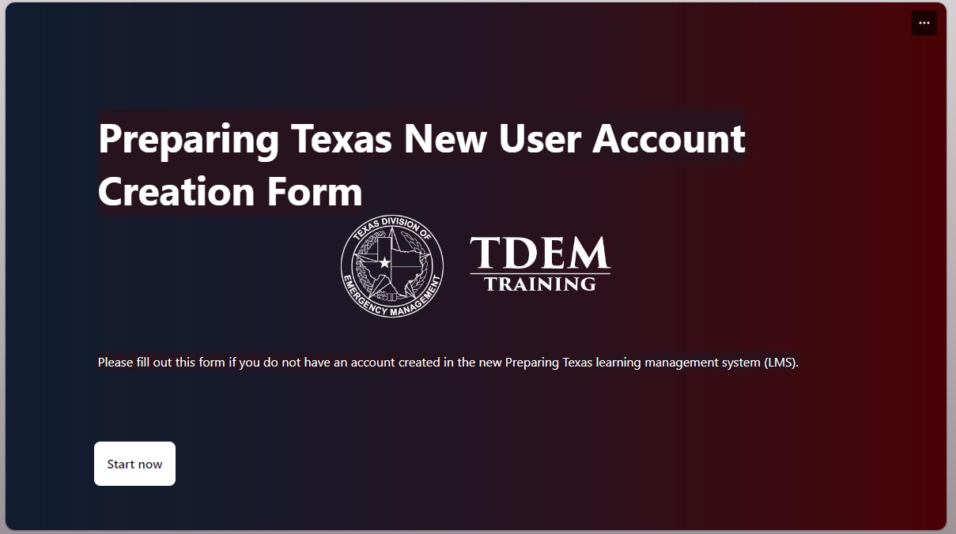

Click “Start Now” and it will have you fill out a form which you will submit upon completion. The state will send you your account info after they create an account for you which can take up to 24 hours. Once you have an account, your user name will be your FEMA SID number and you will have to change your password.

Continued below…

After those steps are completed, please [tdem.geniussis.com/PublicWelcome.aspx](https://tdem.geniussis.com/PublicWelcome.aspx) and sign in. You login will be your FEMA SID number and you will have to click on forgot password to set one up if a link was not provided in an email.

